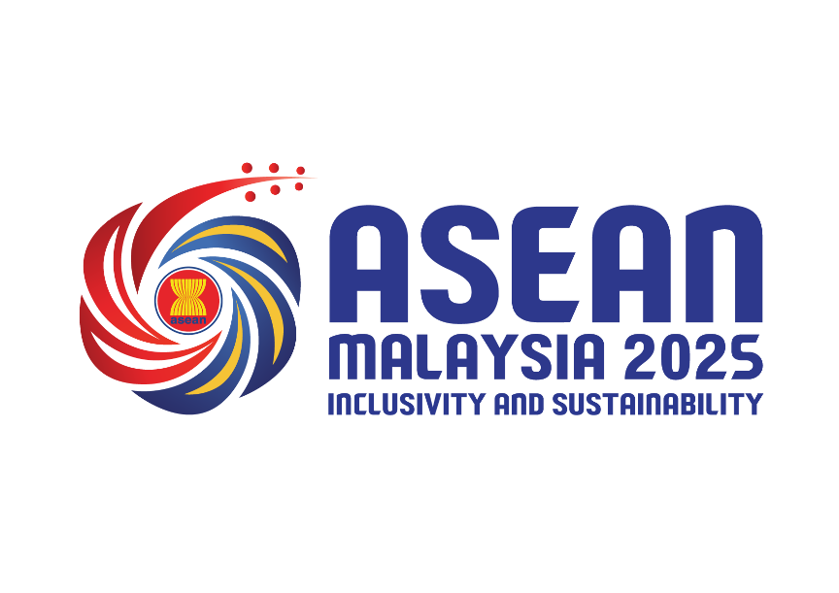

ASEAN INTERGOVERNMENTAL COMMISSION ON HUMAN RIGHTS (AICHR) PRESS RELEASE ON THE DEADLY EARTHQUAKES IN MYANMAR AND THAILAND ON 28 MARCH 2025

2 APRIL 2025

The ASEAN Intergovernmental Commission on Human Rights (AICHR) expresses its profound sorrow over the devastating earthquakes and aftershocks that struck Myanmar on 28 March 2025 which also affected neighbouring countries including Thailand. This disaster has claimed thousands of lives with scores missing and injured. Catastrophic damage has been inflicted on homes, infrastructures, places of worship, and buildings of cultural heritage and significance.

AICHR extends its deepest condolences to the families of victims and stands in solidarity with the peoples of Myanmar and Thailand during this difficult time. We acknowledge the swift response of the relevant parties and global community in mobilising rescue and relief efforts. It is important that humanitarian assistance reaches all affected communities and areas equitably and indiscriminately without delay, with special attention to vulnerable and marginalised populations.

AICHR emphasises the importance of upholding human rights during emergency responses, and for aid to be distributed equitably. Measures taken to provide essential medical care and health-care services, and access to medical facilities should prioritise vulnerable and marginalised groups including women, children, the elderly, and persons with disabilities. We also urge the immediate facilitation of humanitarian access to all affected communities and areas without disruption and discrimination, in line with international humanitarian response principles.

The ASEAN Foreign Ministers’ Statement on the Outcome of the Special Emergency Meeting of ASEAN Foreign Ministers in the Aftermath of the Earthquake in Myanmar and Thailand of 30 March 2025 reaffirmed the importance of a safe and conducive environment in Myanmar to ensure the delivery of lifesaving humanitarian assistance, encouraged all Myanmar stakeholders to focus on humanitarian assistance to facilitate relief efforts, and welcomed Myanmar’s readiness to ensure humanitarian aid reaches those in need, in a timely and effective manner without disruption and discrimination.

AICHR shares its deep sympathy and concern for the people of Myanmar during this tragic time that has compounded existing challenges. Given the circumstances, safe, swift and uninterrupted delivery of humanitarian aid and relief services to all affected communities and areas is important.

AICHR welcomes the measures already taken by numerous parties, including ASEAN Member States, ASEAN Coordinating Centre for Humanitarian Assistance on Disaster Management (AHA Centre), United Nations (UN) and dialogue partners, to assist Myanmar. In the spirit of our shared ASEAN commitment to human rights, AICHR supports enhanced efforts to provide effective and timely aid and relief to Myanmar. AICHR stands ready to work and collaborate with ASEAN sectoral bodies and entities, and the international community pursuant to its mandate to provide any needed guidance, assistance and services to Myanmar and Thailand.

Together, let us support the resilience and recovery of the affected communities.

******

