CV of AICHR Representatives 2022-2024

BRUNEI DARUSSALAM
H.E Hajah Nor Hashimah Haji Mohammed Taib

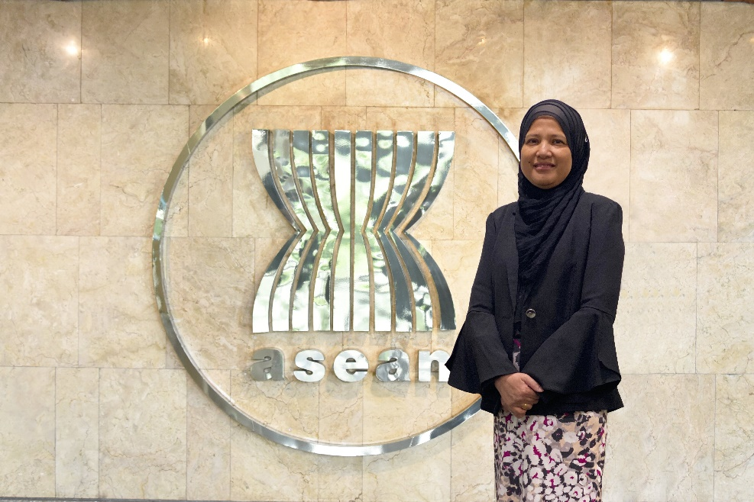
Education:
- Fiqh Muamalat Professional Programme, Centre for Islamic Banking Finance and Management.
- Postgraduate Diploma Guaman Syarie’, Universiti Brunei Darussalam.
- Barrister at Law (Lincoln’s) Inn.
- LLB (Hons) University College Wales, Aberyswyth, UK.

Career:
- 2020-present: Deputy Permanent Secretary, Prime Minister’s Office, Brunei Darussalam.
- 2018-2020: Assistant Solicitor General (Civil Division), Attorney General’s Chambers, Brunei Darussalam.
- 2006-2018: Assistant Solicitor General and Head International Affairs Division, Attorney General’s Chambers, Brunei Darussalam.
- 1998-2006: Civil Division, at the Attorney General’s Chambers, Brunei Darussalam.
- 1995-1998: International Affairs Division, at the Attorney General’s Chambers, Brunei Darussalam.
- 1992: Legal Officer, at the Attorney General’s Chambers, Brunei Darussalam

CAMBODIA
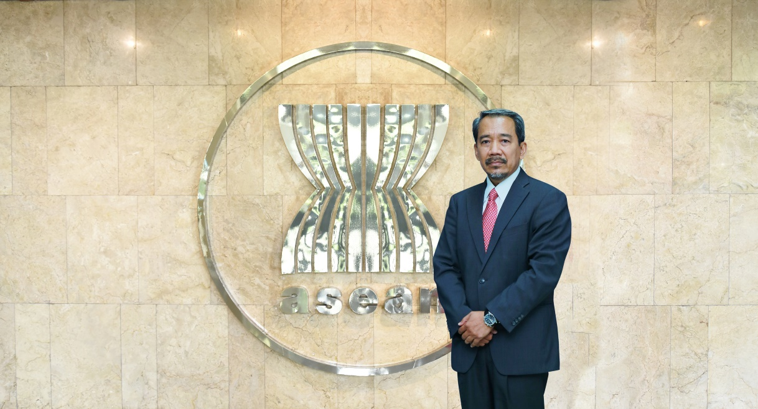
H.E. Keo Remy

Education:
- Bachelor and Master of Law

Career:
- 2018-Present: Delegate Minister attached to the Prime Minister, Royal Government of Cambodia.
- 2017-Present: Permanent Vice Chairman, Royal Government Task Force on the Extraordinary Chambers in the Courts of Cambodia Proceedings.
- 2016-Present: President, Cambodia Human Rights Committee.
- 2010-Present: Member of the Board, National Council for the Anti-Corruption Unit.
- 2008-2018: Secretary of State, Office of the Council of Ministers.
- 1998-2008: Member of Parliament and Vice-Chairman of the 7th Committee of the National Assembly.

INDONESIA

H.E. Yuyun Wahyuningrum

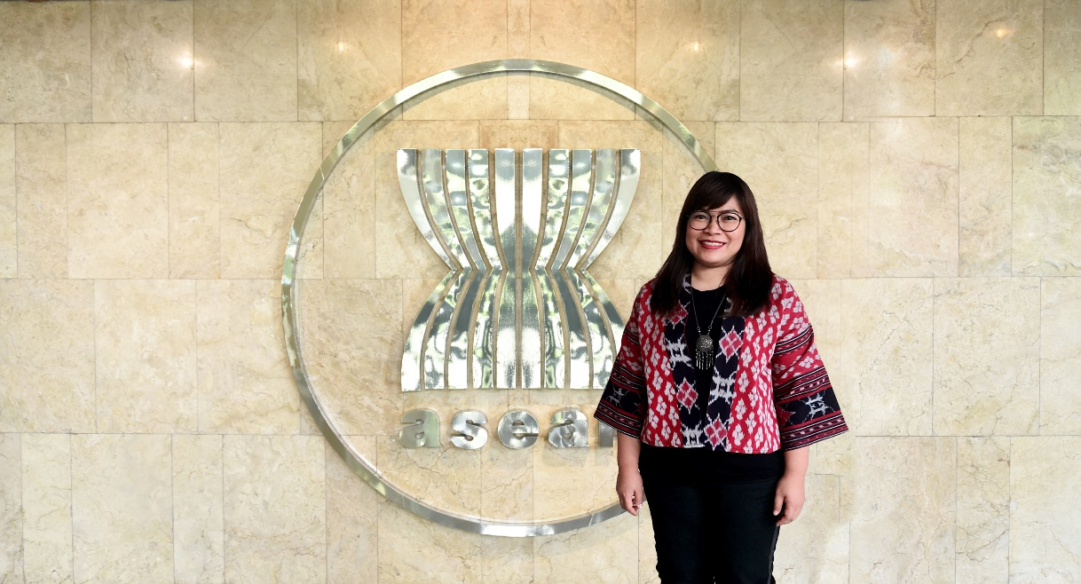
Education:

- PhD Candidate at The Global Governance Law and Social Justice, at the International Institute of Social Studies in The Hague, Erasmus University Rotterdam (2016 – onwards).
- MA Human Rights, Mahidol University, Thailand, 2007.
- Diploma, Library Science, University of Indonesia, 1995.

Career:

- 2015-2017: Team Leader of EU-ASEAN Human Rights Dialogue (READI) Human Rights Facility.
- 2014-2018: Senior Advisor to The ASEAN Parliamentarians for Human Rights (APHR).
- 2009-2010: Policy Advisor on ASEAN, Oxfam International (Hong Kong), Stationed in Jakarta, Indonesia.
- 2008-2009: Program Manager for Human Rights in Southeast and East Asia (including ASEAN), Forum Asia, Bangkok, Thailand.
- 2008-2009: Campaign Coordinator SAPA Task Force ASEAN and Human Rights, hosted by Forum-Asia, Bangkok, Thailand.
- 2004-2005: Program Coordinator for Southeast Asia, Child Workers in Asia, Bangkok, Thailand.
- 2003-2004: Campaign Coordinator on Trafficking against Children in Southeast Asia, Terre des Hommes Netherlands, Jakarta, Indonesia.
- 2001-2003: Program Officer for Trafficking in Persons and Child Labour, American Center for International Solidarity (ACILS), Jakarta, Indonesia.
- 1998-2001: Assistant to Director for Data and Information, National Commission for Child Protection, Jakarta, Indonesia.

LAO PDR

H.E. Amb. Yong Chanthalangsy

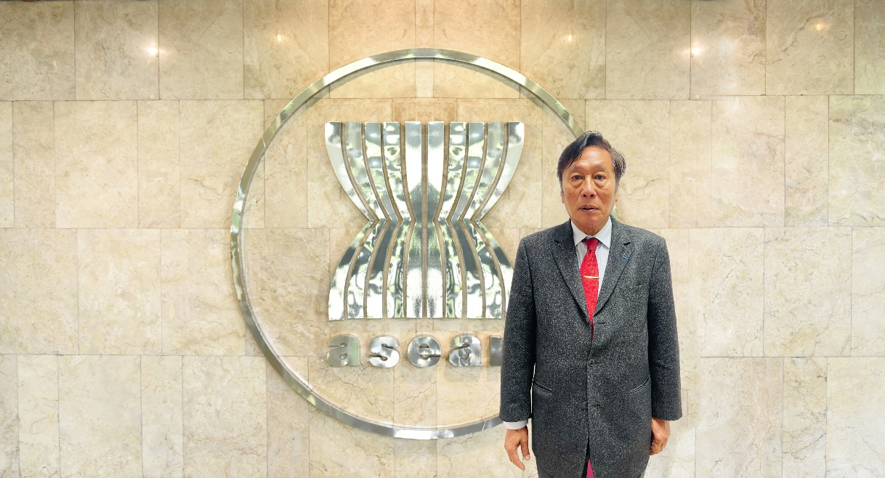

Education:
- Diploma of Journalism
- Ecole Supérieure de Journalisme de Paris
- Centre de Formation des Journalistes de Paris
- Indian Institute of Mass-Communication

Career:
- 2017-Present: Ambassador of Lao PDR to France, Permanent Representative of Lao PDR to UNESCO and Personal Representative of the President of Lao PDR to the Organisation of Francophonie.
- 2014-2017: Director General of the Institute of Foreign Affairs and Member of the ASEAN Level High Level Task Force to review ASEAN Bodies and the ASEAN Secretariat.
- 2009-2013: Ambassador Permanent Representative of Lao PDR to UNOG and Ambassador of Lao PDR to Switzerland, Greece, Turkey, Italy, Malta, Cyprus.
- 2003-2009: Director General of Press Department and Spokesman Of MOFA.
- 2002-2003: Deputy General Director of ASEAN Department (MOFA)
- 2009-2014: Associate Professor, Diplomatic Academy of Viet Nam, Ministry of Foreign Affairs.
- 1998-2002: Senior Officer, FCB, ASEAN Secretariat.
- 1992-1997: Deputy Director General of the Lao News Agency.
- 1982-1995: Chief of International Relations
- 1987-1990: Deputy Editor-in-Chief of Foreign languages News
- 1980-1987: Sub-Editor in English News
- 1977-1979: Sub-Editor in the World News at the Lao News Agency

MALAYSIA

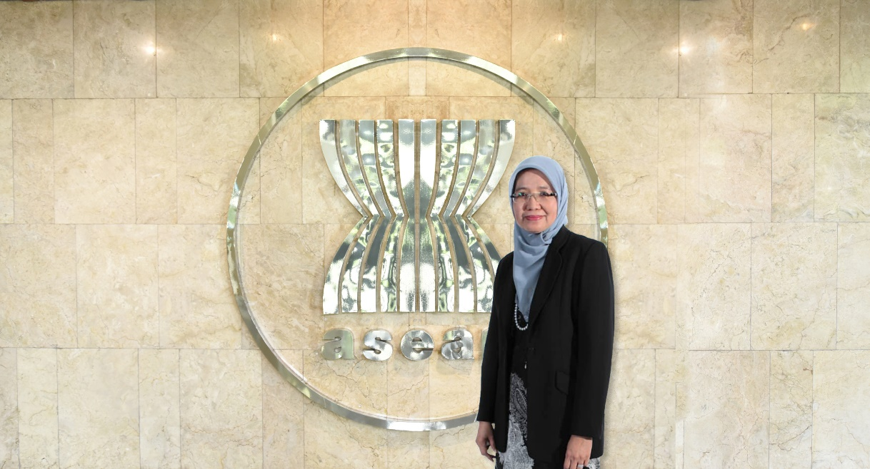
H.E. Prof. Dato’ Dr. Aishah Bidin

Education:

- PhD in Law, London
- LLM, Kent.
- LLB (Hons), Malaya.

Career:

- June 2018-January 2019: Legal Director to Fortify Rights, South East Asia.
- 2014-Present: Fellow and Professor of Corporate and Insolvency Law, Academy of Sciences Malaysia.
- 2014-2019: Council Member, Academy of Sciences Malaysia.
- 2014-2019: Consultant, Legal Affairs Division, Prime Minister’s Department.
- 1986-2020: Professor, Faculty of Law, National University of Malaysia.
- 2011-2019: Member of Board of Directors of Companies Commission of Malaysia, Companies Commission of Malaysia.
- 2013-2019: Commissioner, Human Rights Commission of Malaysia (SUHAKAM).
- 2017-2017: Commonwealth Observer Group for the Election in Kenya, The Commonwealth Secretariat.
- 2013-2016: Member, Executive Council of International Centre for Law and Legal Studies (I-Cells), Attorney General Chambers, Putrajaya.
- 2015-2015: Commonwealth Observer Group for Sri Lanka Parliamentary Elections, The Commonwealth Secretariat.
- 2009-2014: Dean, Faculty of Law National University of Malaysia.

MYANMAR

[TO BE CONFIRMED]

PHILIPPINES

H.E Ambassador Belinda M. Ante

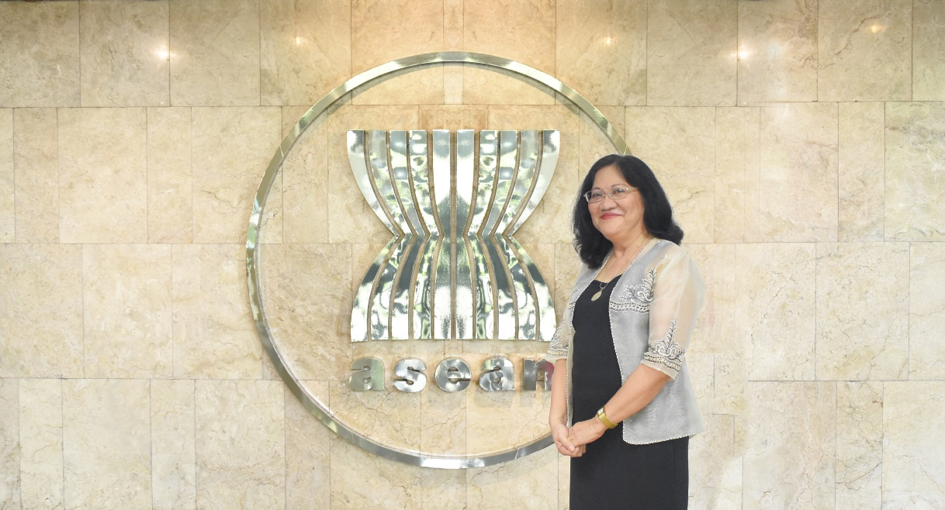

Education:
- A.B. Political Science, University of the Philippines, 1984
- Bachelor of Law, University of London, 1988

Career:
- November 2013 – August 2020: Ambassador Extraordinary and Plenipotentiary to the Netherlands and Permanent Representative to the Organization for the Prohibition of Chemical Weapons (OPCW).
- April 2010 – November 2013: Assistant Secretary, Office of Consular Affairs (concurrently Chairman, National Committee on Illegal Entrants)
- August 2008 – April 2010: Consul General, Philippine Consulate General Macau SAR
- January 2006 – August 2008: Minister and Consul General, Philippine Embassy in Beijing
- 2005 – 2006: First Secretary and Consul, then as Minister and Consul General, Philippine Embassy in Beijing.
- March 2001 – 2024: Director [concurrently Special Assistant Office of Undersecretary for Administration] Office of Personnel and Administrative Services
- August 1997 – 1998 : Second Secretary and Consul, Philippine Embassy in Brussels
- June 1999 – January 2001: First Secretary and Consul, Philippine Embassy in Brussels
- January 1996 – 1997: Consul, Philippine Consulate General in Milan
- January 1995 – 1996: Vice Consul, Philippine Consulate General in Milan
- 1991 – 1994: Special Assistant, Undersecretary Padilla [concurrently Board Secretary of Board of Foreign Service Administration]
- May 1990 – 1991: Assistant Director, Office of Legal Affairs.

SINGAPORE

H.E. Dr. Shashi Jayakumar

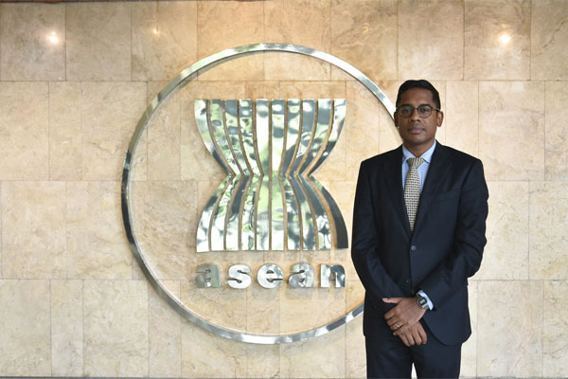
Education:
- Doctor of Philosophy (History), Balliol College, Oxford University.
- Master of Studies (Historical Research) Balliol College, Oxford University.
- Bachelor of Arts (History & English), St Hugh’s College, Oxford University.

Career:
- 2017 to present: Executive Coordinator, Future Issues and Technology, S. Rajaratnam School of International Studies, Nanyang Technological University
- 2015 to present: Head, Centre of Excellence for National Security, S. Rajaratnam School of International Studies,S. Rajaratnam School of International Studies, Nanyang Technological University.
- 2014 - 2015: Deputy Head, Centre of Excellence for National Security, S. Rajaratnam School of International Studies, Nanyang Technological University.
- 2011 - 2014: Senior Visiting Research Fellow, Lee Kuan Yew School of Public Policy
- 2010 - 2011: Director, Elderly Policy, Ministry of Community Development, Youth and Sports, Singapore.
- 2008 - 2010: Deputy Director, Labour Market Analysis Unit, Ministry of Manpower, Singapore.
- 2006 - 2008: Section Head, Ministry of Defence, Singapore.
- 2004 - 2005: Assistant Director, Information Policy (Content) Unit, Ministry of Information, Communications and the Arts, Singapore.
- 2002 - 2004: Research Analyst, Ministry of Defence.
- 2002 - 2017: Member of the Singapore Administrative Service.

THAILAND

H.E. Prof. Amara Pongsapich Ph.D.

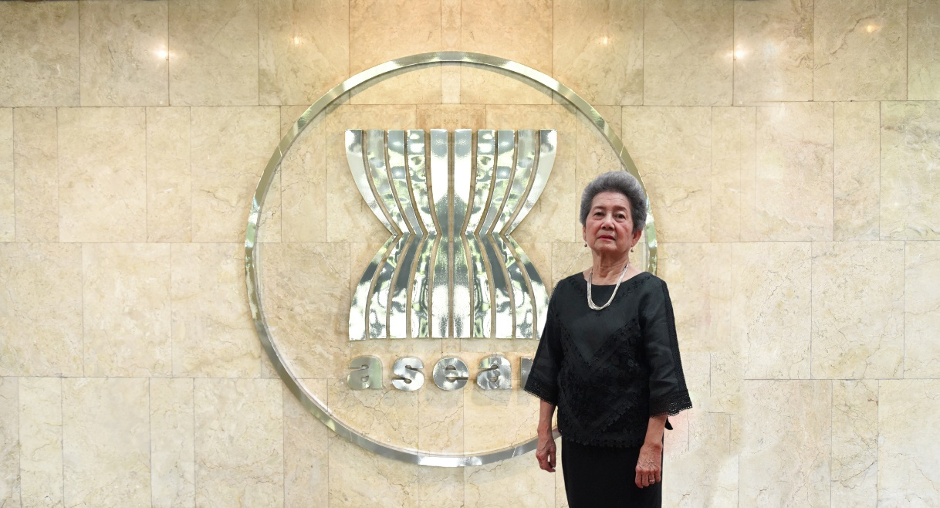

Education:
- Ph.D. in Anthropology, University of Washington, Seattle, U.S.A.
- M.A. in Anthropology, University of Washington, Seattle, U.S.A.
- B.A. in Anthropology, University of California, Davis, U.S.A.

Career:
- 2019-2021: Representative of Thailand to ASEAN Intergovernmental Commission on Human Rights
- 2009-2015: Chair of the National Human Rights Commission of Thailand.
- 2007-2008: Chair of the Sub-committee on Consumers Rights, Office of the National Broadcasting and Telecommunications Commission of Thailand.
- 2006-2009: Director of the Center for Peace and Conflict Studies, Chulalongkorn University.
- 2002-2006: Dean of the Faculty of Political Science, Chulalongkorn University.
- 1993-1996: Vice President for Research, Chulalongkorn University.
- 1990-1996: Board Member of the United Nations International Research and Training Institute for the Advancement of Women (INSTRAW).
- 1989-1991: Board Member of the National Commission on Women’s Affairs of Thailand.
- 1987-93, 1997-2002: Director of the Social Research Institute, Chulalongkorn University.
- 1974-2006: Department of Sociology and Anthropology, Faculty of Political Science, Chulalongkorn University.

VIET NAM

H.E. Ambassador Prof. Dr. Nguyen Thai Yen Huong

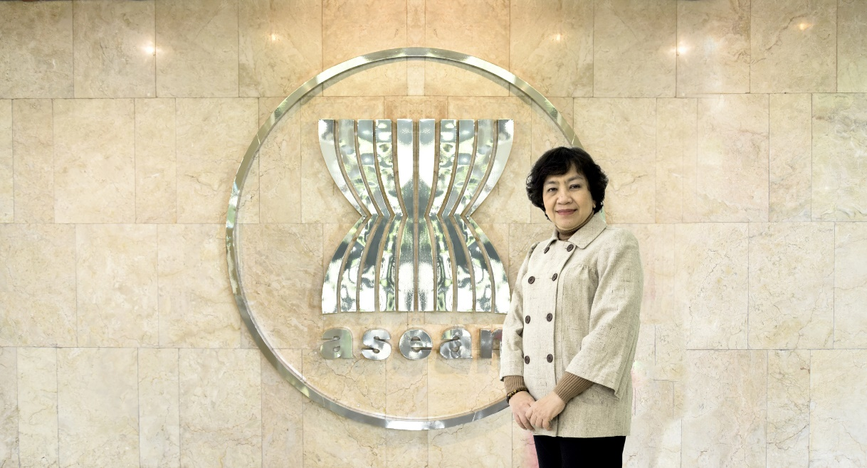

Education:
- PhD in Contemporary World History, University of Social Sciences and Humanities, Viet Nam National University, Ha Noi, Viet Nam.
- M.A. in International Relations, University of Notre Dame, Indiana, USA.
- B.A. in International Relations, College of Foreign Affairs, Viet Nam.

Career:
- 2019-2021: Representative of Viet Nam to the AICHR.
- 2015-now: Professor, Senior Lecturer and Research Fellow, Diplomatic Academy of Viet Nam, Ministry of Foreign Affairs.
- 2014-2016: Co-Chair, Council for Security Cooperation in the Asia-Pacific (CSCAP).
- 2012-now: Ambassador, Ministry of Foreign Affairs of Viet Nam.
- 2011-2018: Vice President, Diplomatic Academy of Viet Nam, Ministry of Foreign Affairs.
- 2009-2014: Associate Professor, Diplomatic Academy of Viet Nam, Ministry of Foreign Affairs.
- 2008-2010: Director of Post-Graduate Program, Diplomatic Academy of Viet Nam, Ministry of Foreign Affairs.
- 2003-2007: Deputy Director of Post-Graduate Program, Diplomatic Academy of Viet Nam, Ministry of Foreign Affairs.
- 1996-2002: Deputy Director, Faculty of American and European Studies, Diplomatic Academy of Viet Nam, Ministry of Foreign Affairs.

****

