BRUNEI DARUSSALAM

H.E Hajah Nor Hashimah Haji Mohammed Taib

Education:
- Fiqh Muamalat Professional Programme, Centre for Islamic Banking Finance and Management.
- Postgraduate Diploma Guaman Syarie’, Universiti Brunei Darussalam.
- Barrister at Law (Lincoln’s) Inn.
- LLB (Hons) University College Wales, Aberyswyth, UK.
Career:
- 2020-present: Deputy Permanent Secretary, Prime Minister’s Office.
- 2018-2020: Assistant Solicitor General (Civil Division), Attorney General’s Chambers.
- 2006-2018: Assistant Solicitor General and Head International Affairs Division, Attorney General’s Chambers.
- 1998-2006: Civil Division, at the Attorney General’s Chambers.
- 1995-1998: International Affairs Division, at the Attorney General’s Chambers.
- 1992: Legal Officer, at the Attorney General’s Chambers, Brunei Darussalam

- 08 February 2018: Promoted and appointed as Permanent Secretary at the Prime Minister’s Office, Brunei

Darussalam.

- 26 June 2012: Seconded to Prime Minister’s Office, Brunei Darussalam.

- 01 November 2009: Promoted to Senior Counsel at Attorney General’s Chambers, Brunei Darussalam.

- 01 March 2004: Promoted to Deputy Senior Counsel at Attorney General’s Chambers, Brunei Darussalam.

- 01 November 1993: Legal Officer at Attorney General’s Chambers, Brunei Darussalam.

CAMBODIA

H.E. Mrs. Polyne Hean
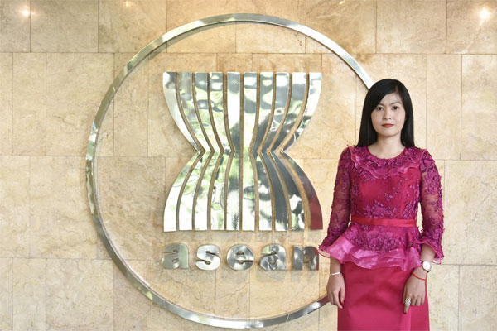

Education:

- Master in Development Studies, School of International Development, University of East Anglia.

- Master in Democracy and Governance, Department of Government, Georgetown University.

- Bachelor of Education in Teaching English as a Foreign Language, Institute of Foreign Languages, Royal University of Phnom Penh.

- Bachelor of Economics, Faculty of Economics, Royal University of Law and Economics.

Career:

- February 2019-present: Representative of Cambodia to the ASEAN Intergovernmental Commission on Human Rights (AICHR).

- December 2018-present: Director-General, General Department of International Cooperation, Office of the Council of Ministers (OCM).

- October 2017-present: Vice President, Cambodian Human Rights Committee.

- 2015-present: CM Focal Point, National Committee on NTMs and NTR.

- 2015-present: Member, National Committee to Counter Trafficking.

- 2013-present: Board Member, iAB Group.

- 2013-present: Vice Present, iAB Architecture and Construction Co., Ltd.

- 2016-2018: Representative of Cambodia to the AICHR.

- February 2015-December 2018: Director, ASEAN Department, OCM.

- April 2012-February 2015: Official, ASEAN Department, OCM.

- 2011-2012: Official, Cabinet of Samdech Vibol Panha SOK An, OCM.

INDONESIA

H.E. Yuyun Wahyuningrum

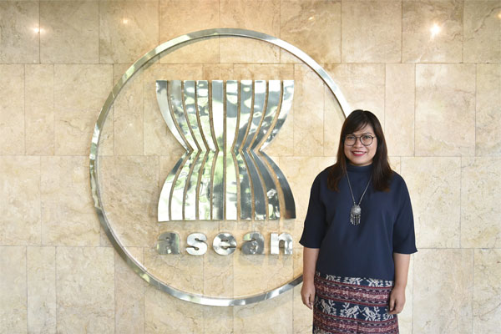

Education:

- PhD Candidate at The Global Governance Law and Social Justice, at the International Institute of Social Studies in The Hague, Erasmus University Rotterdam (2016 – onwards).

- MA Human Rights, Mahidol University, Thailand, 2007.

- Diploma, Library Science, University of Indonesia, 1995.

Career:

- 2015-2017: Team Leader of EU-ASEAN Human Rights Dialogue (READI) Human Rights Facility.

- 2014-2018: Senior Advisor to The ASEAN Parliamentarians for Human Rights (APHR).

- 2009-2010: Policy Advisor on ASEAN, Oxfam International (Hong Kong), Stationed in Jakarta, Indonesia.

- 2008-2009: Program Manager for Human Rights in Southeast and East Asia (including ASEAN), Forum Asia, Bangkok, Thailand.

- 2008-2009: Campaign Coordinator SAPA Task Force ASEAN and Human Rights, hosted by Forum-Asia, Bangkok, Thailand.

- 2004-2005: Program Coordinator for Southeast Asia, Child Workers in Asia, Bangkok, Thailand.

- 2003-2004: Campaign Coordinator on Trafficking against Children in Southeast Asia, Terre des Hommes Netherlands, Jakarta, Indonesia.

- 2001-2003: Program Officer for Trafficking in Persons and Child Labour, American Center for International Solidarity (ACILS), Jakarta, Indonesia.

- 1998-2001: Assistant to Director for Data and Information, National Commission for Child Protection, Jakarta, Indonesia.

LAO PDR

H.E. Malayvieng Sakonhninhom

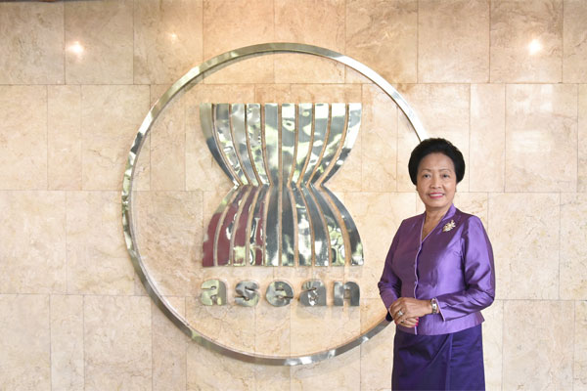

Education:

- Diploma of Diplomacy at the Institut International d'Administration Publique, Paris, France.

- Master of International Law with Honors, Ukraine, the Soviet Union.

- Graduated from the Institut Royal de Droit et d'Administration, Vientiane.

- High school: Ecole Sainte Jeanne-Antide and Lycee de Pakse.

Career:

- 1994-present: Visiting Professor on International Law and International Relations.

- 2015-2018: Spouse of Ambassador to India.

- 2011-2015: Ambassador Extraordinary and Plenipotentiary of the Lao PDR to the Republic of the Philippines.

- 2004-2010: Acting Director General and Director General of the Institute of Foreign Affairs, Ministry of Foreign Affairs of the Lao PDR.

- 2001-2004: Head of the Lao Task force for Lao-Thai Extradition Vangtao-Songmek case.

- 2004: Track Two Diplomacy: ASEAN Think tanks of ASEAN Charter Drafting.

- 1994-2004: Member of the Lao National Committee on Energy.

- 1994-2004: Director of Division and Deputy Director General of Department of Treaties and Law, Ministry of Foreign Affairs of the Lao PDR.

- 1982-1993: Desk officer and Deputy Director of Division at Press Department, Ministry of Foreign Affairs of the Lao PDR.

MALAYSIA

H.E. Mr. Eric Paulsen

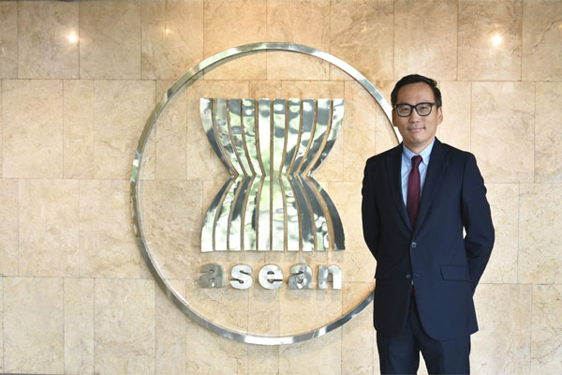

Education:

- Master of Law in Human Rights, University College London.

- Certificate in Legal Practice, Legal Profession Qualifying Board, Malaysia.

- Bachelor of Law, University of London.

Career:

- June 2018-January 2019: Legal Director to Fortify Rights, South East Asia.

- January 2014-May 2018: Executive Director to Lawyers for Liberty, Malaysia.

- January 2011-December 2013: Co-founder & Adviser to Lawyers for Liberty, Malaysia.

- April-July 2012: Protection Officer (Protection Surge Capacity Project), UN High Commissioner for Refugees, Lebanon.

- August-November 2011: Protection Officer (Protection Surge Capacity Project), UN High Commissioner for Refugees, Myanmar.

- December 2008-May 2009: Protection Officer (Protection Surge Capacity Project), UN High Commissioner for Refugees, South Africa.

- September-November 2008: Consultant, Human Rights Watch.

- February-August 2007: Protection Officer (Protection Surge Capacity Project), UN High Commissioner for Refugees, Nepal.

- December 2005-September 2006: Protection Officer (Protection Surge Capacity Project), UN High Commissioner for Refugees, Bangladesh.

- October 2004-June 2005: Human Rights Officer (IUNV), UN Office of the High Commissioner for Human Rights, Cambodia.

- June 2002-September 2004: Coordinator, Suara Rakyat Malaysia (SUARAM), Malaysia.

- January 1998-August 2000: Advocate & Solicitor, Messrs Karpal Singh & Company, Malaysia.

- July 1995-July 1996: Lecturer in Law, Advance Tertiary College, Malaysia.

MYANMAR

H.E. Ambassador Maung Wai

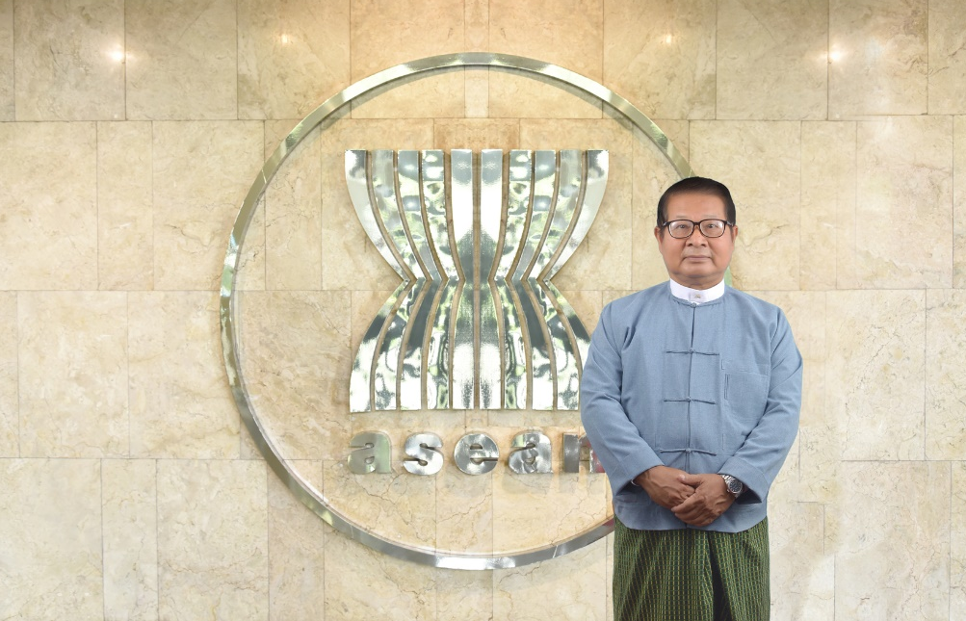

Education:
- Bachelor of Agriculture, Yezin Agricultural University.
- Diploma in Agriculture.

Career:
- 2018-now: Advisor to the Office of the President.
- 2016-2017: Ambassador to India.
- 2011-2016: Ambassador, Permanent Mission of Myanmar to United Nations, Geneva.
- 2010-2011: Director-General, International Organizations and Economic Department, Ministry of Foreign Affairs.
- 2009-2010: Director-General, ASEAN Affairs Department, Ministry of Foreign Affairs.
- 2008-2009: Deputy Director-General, Consular and Legal Affairs Department, Ministry of Foreign Affairs.
- 2005-2007: Minister Counsellor, Permanent Mission of Myanmar in New York.
- 2003-2005: Director, Ministry of Foreign Affairs.
- 1999-2003: Minister Counselor, Myanmar Embassy, Phnom Penh.
- 1995-1999: Assistant Director/ Deputy Director, Ministry of Foreign Affairs.
- 1992-1995: Second Secretary, Myanmar Embassy, Washington DC.
- 1989-1992: Head of Branch I, Ministry of Foreign Affairs.
- 1984-1989: Third Secretary/ Second Secretary, Myanmar Embassy, Dhaka, Bangladesh.
- 1980-1984: Attache, Ministry of Foreign Affairs.

SINGAPORE

H.E. Dr. Shashi Jayakumar

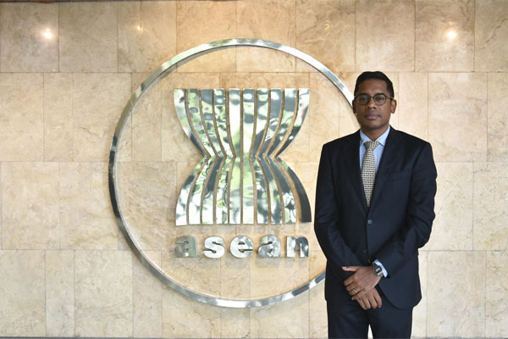

Education:

- Doctor of Philosophy (History), Balliol College, Oxford University.

- Master of Studies (Historical Research) Balliol College, Oxford University.

- Bachelor of Arts (History & English), St Hugh’s College, Oxford University.

Career:

- 2017 to present: Executive Coordinator, Future Issues and Technology, S. Rajaratnam School of International Studies, Nanyang Technological University.

- 2015 to present: Head, Centre of Excellence for National Security, S. Rajaratnam School of International Studies,S. Rajaratnam School of International Studies, Nanyang Technological University.

- 2014 - 2015: Deputy Head, Centre of Excellence for National Security, S. Rajaratnam School of International Studies, Nanyang Technological University.

- 2011 - 2014: Senior Visiting Research Fellow, Lee Kuan Yew School of Public Policy
- 2010 - 2011: Director, Elderly Policy, Ministry of Community Development, Youth and Sports, Singapore.

- 2008 - 2010: Deputy Director, Labour Market Analysis Unit, Ministry of Manpower, Singapore.

- 2006 - 2008: Section Head, Ministry of Defence, Singapore.

- 2004 - 2005: Assistant Director, Information Policy (Content) Unit, Ministry of Information, Communications and the Arts, Singapore.

- 2002 - 2004: Research Analyst, Ministry of Defence.

- 2002 - 2017: Member of the Singapore Administrative Service.

THAILAND

H.E. Prof. Amara Pongsapich Ph.D.

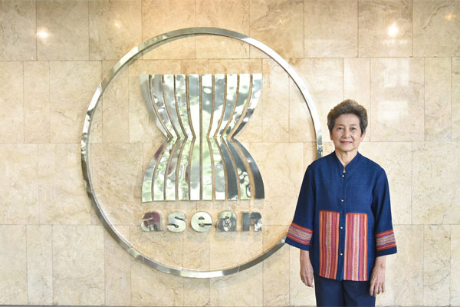

Education:

- Ph.D. in Anthropology, University of Washington, Seattle, U.S.A.

- M.A. in Anthropology, University of Washington, Seattle, U.S.A.

- B.A. in Anthropology, University of California, Davis, U.S.A.

Career:

- 2009-2015: Chair of the National Human Rights Commission of Thailand.

- 2007-2008: Chair of the Sub-committee on Consumers Rights, Office of the National Broadcasting and Telecommunications Commission of Thailand.

- 2006-2009: Director of the Center for Peace and Conflict Studies, Chulalongkorn University.

- 2002-2006: Dean of the Faculty of Political Science, Chulalongkorn University.

- 1993-1996: Vice President for Research, Chulalongkorn University.

- 1990-1996: Board Member of the United Nations International Research and Training Institute for the Advancement of Women (INSTRAW).

- 1989-1991: Board Member of the National Commission on Women’s Affairs of Thailand.

- 1987-93, 1997-2002: Director of the Social Research Institute, Chulalongkorn University.

- 1974-2006: Department of Sociology and Anthropology, Faculty of Political Science, Chulalongkorn University.

VIET NAM

H.E. Ambassador Prof. Dr. Nguyen Thai Yen Huong

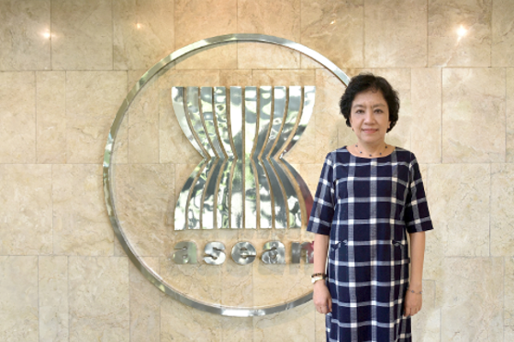

Education:

- PhD in Contemporary World History, University of Social Sciences and Humanities, Viet Nam National University, Ha Noi, Viet Nam.

- M.A. in International Relations, University of Notre Dame, Indiana, USA.

- B.A. in International Relations, College of Foreign Affairs, Viet Nam.

Career:

- 2019-2021: Representative of Viet Nam to the AICHR.

- 2015-now: Professor, Senior Lecturer and Research Fellow, Diplomatic Academy of Viet Nam, Ministry of Foreign Affairs.

- 2014-2016: Co-Chair, Council for Security Cooperation in the Asia-Pacific (CSCAP).

- 2012-now: Ambassador, Ministry of Foreign Affairs of Viet Nam.

- 2011-2018: Vice President, Diplomatic Academy of Viet Nam, Ministry of Foreign Affairs.

- 2009-2014: Associate Professor, Diplomatic Academy of Viet Nam, Ministry of Foreign Affairs.

- 2008-2010: Director of Post-Graduate Program, Diplomatic Academy of Viet Nam, Ministry of Foreign Affairs.

- 2003-2007: Deputy Director of Post-Graduate Program, Diplomatic Academy of Viet Nam, Ministry of Foreign Affairs.

- 1996-2002: Deputy Director, Faculty of American and European Studies, Diplomatic Academy of Viet Nam, Ministry of Foreign Affairs.

